­­­­

Brussels, 19 January 2011 (Updated 22 February 2021)

Precision seeds

Euroseeds product specifications

for vegetable precision seeds

# Table of contents

Precision seeds 0

Table of contents 1

Euroseeds vegetable seed product specifications 2

General definitions 3

Euroseeds product specifications of precision seeds: varietal purity 4

Euroseeds product specifications of precision seeds: germination 5

Euroseeds recommendation on seed health requirements 8

# Euroseeds vegetable seed product specifications

These product specifications for germination of precision seeds, varietal purity of precision seeds and seed health requirements are based upon Euroseeds recommended standards. These product specifications are not meant to be absolute minimum standards for delivery. If the quality tests of company X indicate a lower quality-level than given in these specifications, company X will inform prospective seed users. This communication is aimed at informing professional seed users about the quality they can expect, so they can make their own assessment and decide if these seeds meet their requirements.

Vegetable growing has become a highly specialized and intensive activity. As a result of the ever-increasing demand for better quality, vegetable growers and plant raisers require an improved quality of the basic material. The demand for specific seed forms and more information about seed quality has strongly increased to better influence emergence and required number of plants. Seed is a natural product. The often-varying environmental conditions thus influence final results. It is therefore often not possible to give detailed information about emergence and other physical seed characteristics. To meet the wishes of clients as much as possible company X has made up quality standards for the various seed categories. The germination percentages mentioned are company X minimum required figures and made up according to ISTA methods and tolerances.

# General definitions

* Normal Seed

In general, normal seed has not been subjected to special processes. It is sold by weight and/or by count, depending on the product. Normal seed complies with EC standards.

* Precision Seed

Precision seed has been subjected to additional processes. It has a uniform size and high germination. Precision seed is sold by count.

* Priming

Priming is defined as an activation of the germination process with the purpose to obtain faster or more uniform emergence after sowing. Primed seed is sold by count.

* Pelleting

Pelleting is defined as the process of changing the seed form by covering it with a material, the main purpose being to improve uniformity of size and shape resulting in improved sowing ability. Also, additional ingredients may be added. Pelleted seed is sold by count.

* Film coating

Film coating is a full covering, usually pigmented layer, around the seed. The original seed form remains intact. Additional ingredients may be added. Film coating treatments that contain insecticides are normally identifiable by colour coding. Film coated seed is sold by count.

* Glue coating

Glue coating is a process which fixes the applied crop protection products in an almost dust free manner to the seed. A pigment may be added.

* Germination

Germination figures relate to ISTA procedures and are valid at the time of despatch.

* Varietal purity

Varietal purity rate is defined as: the percentage of plants from a seed lot that meets the variety description.

# Euroseeds product specifications of precision seeds: varietal purity

|  |  |
| --- | --- |
| Crop | Minimum % varietal purity  for precision seeds |
| Brassica | 93 |
| Cucumber *(indoor)* | 99 |
| Cucumber *(outdoor)* | (excluding pollinators) 98 |
| Cucumber *(indoor pickling)* | (excluding pollinators) 98 |
| Cucumber *(outdoor pickling)* | (excluding pollinators) 98 |
| Eggplant | 98 |
| Lettuce *(Butter head, Batavia, Iceberg, Cos)* | 98 |
| Lettuce *(other types)* | 95 |
| Melon | 98 |
| Watermelon | 98 |
| Pepper | 97 |
| Squash | 97 |
| Tomato *(fresh)* | 98 |
| Tomato *(processing)* | 95 |

# Euroseeds product specifications of precision seeds: germination

|  |  |
| --- | --- |
| Crop | Minimum % germination  for precision seeds |
| Asparagus | 85 |
| Brassica  *Seed size gradation: 0,20 - 0,25 mm* | 90 |
| Dwarf bean  *1 unit: 100 000 seeds* | 85 |
| Climbing bean | 95 |
| Broad bean  *1 unit: 25 000 seeds* | 85 |
| Beetroot *(monogerm)* | 80 |
| Beetroot *(multigerm)*  *Seed size gradation: 0,50 mm* | 90 |
| Carrot  *Seed size gradation: 0,20 – 0,25 mm* | 85 |
| Celery / Celeriac | 90 (pellets: 90%) |
| Chicory Witloof  *Seed size gradation: 0,20 – 0,25 mm* | 85 (pellets: 85%) |
| Corn salad  *Seed size gradation: 0,20 – 0,25 mm* | 85 |
| Cucumber *(indoor)* | 92 |
| Cucumber *(outdoor)* | 92 |
| Cucumber *(indoor pickling)* | 92 |
| Cucumber *(outdoor pickling)* | 88 |
| Eggplant | 90 |
| Endive | 90 (pellets: 92%) |
| Fennel  *Seed size gradation: 0,20 – 0,50 mm* | 90 (pellets: 90%) |
| Leek *(OP)*  *Seed size gradation: 0,20 – 0,25 mm* | 90 (pellets: 90%) |
| Leek *(F1)*  *Seed size gradation: 0,20 – 0,25 mm* | 85 (pellets: 85%) |
| Lettuce *(Butter head, Batavia, Iceberg, Cos)* | 93 (pellets: 95%) |
| Lettuce *(other types)* | 93 (pellets: 95%) |
| Melon *(Charentais type)* | 95 |
| Melon *(other types)* | 90 |
| Onion *(Bulb)*  *Seed size gradation: 2,00 – 2,75 mm*  *1 unit: 250 000 seeds* | 90 |
| Onion *(bunching)*  *Seed size gradation: 0,25 mm*  *1 unit: 250 000 seeds* | 90 |
| Parsley  *Seed size gradation: 0,20 – 0,25 mm* | 87 |
| Pea | 85 - 88 |
| Radicchio / Sugarloaf | 88 (pellets: 88%) |
| Radish | 92 |
| Scorzonera | 80 |
| Spinach  *Seed size gradation: 0,75 mm* | 85 |
| Sweet corn *(normal sugary)* | 90 |
| Sweet corn *(super sweet)* | 85 |
| Sweet / Hot pepper | 90 |
| Squash | 92 |
| Tomato | 92 |
| Watermelon *(normal type)* | 90 |
| Watermelon *(seedless type)* | 85 |

# Euroseeds recommendation on seed health requirements

In order to supply sufficiently healthy vegetable seeds and in order to meet the requirements of EU Council Directive 2002/55/EC, company X uses various disease risk management strategies to prevent and control seed transmitted diseases. These may include and are not limited to seed health testing programs, protected seed production, field inspections, seed treatments and other effective seed disinfection methods. ISHI-VEG has developed the Manual of Seed Health Testing Methods, which includes state of the art seed health testing protocols. Company X follows the ISHI-VEG recommended minimum sizes of a representative sample for seed health testing. Information regarding the ISHI-VEG seed health test protocols and recommended minimum sample sizes can be found at: <https://www.worldseed.org/>

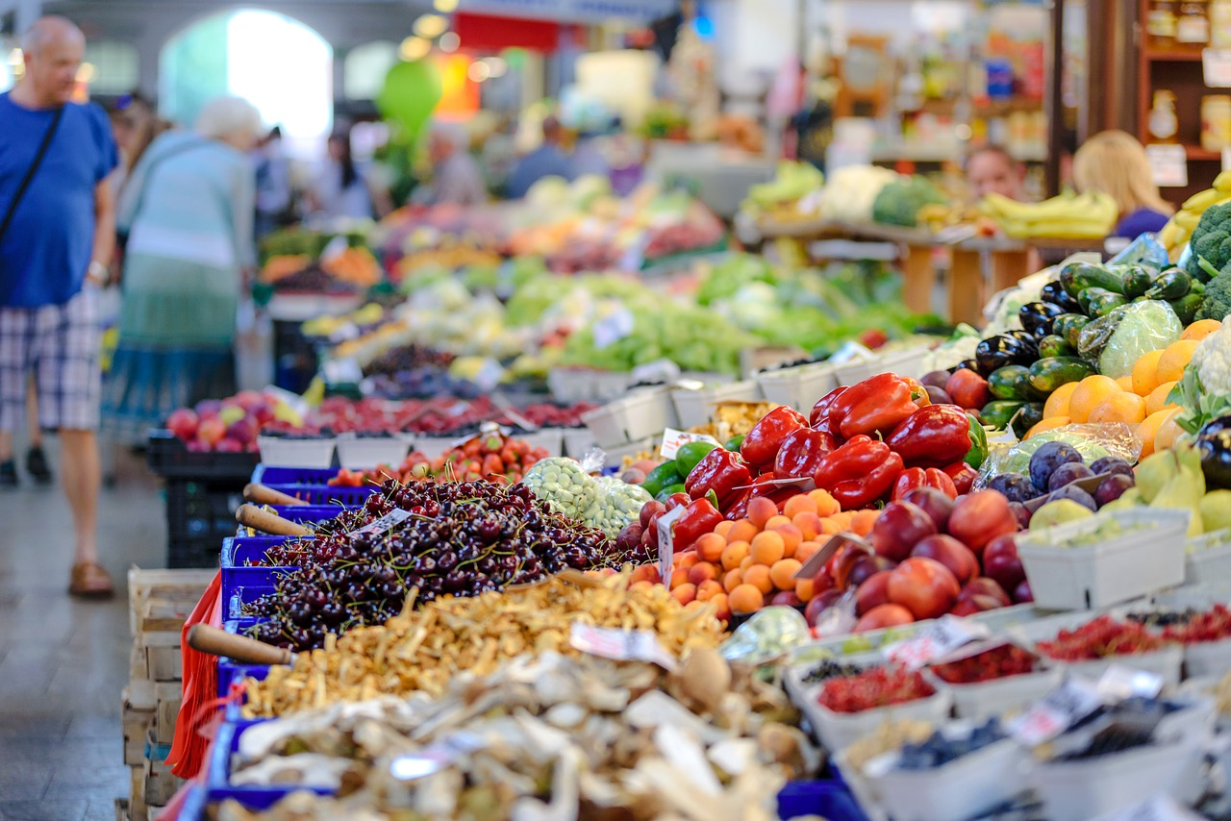

../src/Pattern/v.jpg



Avenue des Arts 52  
 1000 Brussels

[www.euroseeds.eu](http://www.euroseeds.eu)

#EmbracingNature

